1.0 INTRODUCTION

Agriculture plays a vital role in the economy, and facilitating direct communication between farmers and consumers can significantly enhance the agricultural market. The project, titled “E-Agriculture for Direct Marketing of Food Crops Using Chatbot (DMCF Chatbot),” is a web-based platform aimed at revolutionizing the way agricultural products are marketed. This system bridges the gap between sellers (farmers) and bidders (buyers) by creating a transparent, efficient, and automated bidding process. Built using HTML, Bootstrap for the front end and PHP for the back end and MySQL for the Database, the platform ensures a user-friendly interface and reliable data management for seamless operations.

The platform allows sellers to showcase their agricultural products for auction, providing essential details such as auction duration, bidding status, and current offers. Buyers can browse ongoing auctions, place bids, and track their participation in real time. The system also incorporates automated email notifications to keep users informed about crucial updates, including new bids, auction closures, and transaction statuses. By integrating a chatbot with 70-80% query accuracy, the platform ensures that vendors can easily find preferred auctions, enhancing user engagement and satisfaction.

Ultimately, DMCF Chatbot aims to create a robust digital marketplace tailored to the unique needs of the agricultural sector. By leveraging technology to connect farmers and consumers directly, the platform promotes transparency, reduces intermediaries, and empowers the farming community to achieve better returns for their produce.

2.0 SYSTEM STUDY
2.1 EXISTING SYSTEM:

Traditional rural markets primarily depend on middlemen to facilitate trade between farmers and buyers. While these intermediaries simplify the selling process, they significantly reduce the income earned by farmers as they claim a substantial share of the profits. Additionally, existing online platforms for agricultural trading are often limited in functionality, lacking features such as real-time communication and automated updates. This creates inefficiencies in transaction processing and leads to slower decision-making. Furthermore, outdated interfaces and insufficient communication tools make it challenging for users, particularly farmers, to navigate these platforms effectively, ultimately discouraging widespread adoption.

The absence of timely updates in these systems adds to the inefficiencies. Users are often unaware of critical changes in the market or auction status, causing delays in decision-making and missed opportunities. This results in reduced profitability for farmers and diminishes the overall utility of these platforms. To fully realize the potential of online agricultural trading, it is essential to address these limitations by incorporating features like real-time communication, automated notifications, and user-friendly design to ensure a more efficient and productive system.

2.1.1 DISADVANTAGE:
1. Reliance on Middlemen: Farmers lose a significant portion of their income due to intermediaries taking a share of profits.
2. Limited Real-Time Communication: Current platforms lack tools for immediate interaction, leading to delays in transactions and updates.
3. Inefficient Update Mechanisms: The absence of automated notifications causes users to miss critical updates about bidding or market changes, reducing efficiency.
4. Poor User Experience: Complex interfaces and lack of intuitive navigation discourage users, especially farmers, from adopting these systems.

2.2 PROPOSED SYSTEM:
The proposed system leverages technology to create a robust platform for direct marketing of food crops, eliminating the need for middlemen. By integrating a web portal with a chatbot, it facilitates seamless communication and bidding for both buyers and sellers. Registered users can initiate new bids, place offers, and communicate effectively within the platform. Automated email notifications provide real-time updates on bidding statuses, market developments, and auction closures, ensuring users remain informed at all times. This system streamlines the trading process and enhances user engagement, addressing many of the challenges faced by existing systems.

A key innovation is the chatbot, which enables instant interaction and assists users in navigating the platform efficiently. By reducing communication barriers, the chatbot fosters direct interactions between buyers and sellers, increasing transparency and trust. This approach not only enhances the overall trading experience but also ensures that participants have access to timely and accurate information, helping them make informed decisions. The system focuses on optimizing the bidding process, from initiation to closure, to support farmers and buyers in achieving their goals effectively.

2.2.1 ADVANTAGE:
1. Direct Marketing: Removes intermediaries, enabling farmers to earn higher profits by directly interacting with buyers.
2. Real-Time Communication: Chatbot integration ensures instant updates and seamless interaction between participants.
3. Automated Notifications: Timely email updates keep users informed about offers, bids, and auction statuses.
4. User-Friendly Interface: A simple and intuitive design makes it easy for users to register, navigate, and participate in auctions.
5. Efficient Bidding Process: Displays critical details like time left and the number of bids, allowing users to make informed decisions quickly.

3.0 SYSTEM SPECIFICATIONS

3.1 HARDWARE REQUIREMENT
Processor : Intel i3 7th gen/AMD Ryzen 3 1st gen/Intel Xeon 2nd gen/AMD EPYC 7001 Series
Memory : DDR3 4GB RAM
Hard Disk : 50GB HDD

3.2 SOFTWARE REQUIREMENT
Operating System : Windows 7/Ubuntu 18.04 LTS/Cent OS 7
Front End : HTML 5, Bootstrap 5, JS
Back End : PHP 7/8
Database : MySQL 5.7

4.0 SYSTEM DESIGN

4.1 INPUT DESIGN

Input design focuses on capturing user data accurately and ensuring it is processed efficiently by the system. The input modules are user-friendly, validated, and designed to minimize errors. Below is a list of modules that capture inputs and their respective data:

The objectives of input design are as follows
The important features are
The input screen is not crowed, as the user can understand the information from the screen.
The input validation is being done at program level to check errors & help messages are to be provided.
The following Input are
- Registration Module
- Login Module
- Auction Creation Module
- Bidding Module
- Review and Moments Module
- Chatbot Module.
- Admin Management Module

4.2 DATABASE DESIGN

- USERS (TABLE)
Table: users
userId | userName | userFirstName | userLastName | userEmail | userPasssword | userPhone | userProfileImg | userAccountNo | userAddress

userRole | userStatus | creaedAT

- AUCTIONS (TABLE)
Table: auctions
aunctionId | auctionTitle | auctionStartPrice | auctionStartDate | auctionEndDate | auctionProductImg | auctionProductType | auctionProductQuantity

auctionProductUnit | auctionAddrees | auctionDescription | auctionCategoryId | auctionCreatedeBy | auctionStatus | createdAt

- CATEGORIES (TABLE)
Table: categories
categoryId | categoryName | categoryImg | categoryStatus | createdAt

- BIDS (TABLE)
Table: bids
bidId | bidAuctionId | bidUserId | bidAmount | createdAt

- TRANS (TABLE)
Table: trans
transId | transTrackingId | transCardNo | transAccountNo | transUserId | transAmount | transAuctionId | createdAt

- USER_ACTIVATE (TABLE)
Table: userActivate
userActivateId | userActivateUserId | userActivateToken | createdAt

- PASS_RESETS (TABLE)
Table: passResets
passResetId | passResetUserID | passResetToken | createdAt

- HEROES (TABLE)
Table: heroes
heroId | heroTitle | heroImg | heroMessage | heroContent | heroStatus | createdAt

- MOMENTS (TABLE)
Table: moments
momentId | momentUserId | momentImg | mmentStatus | craeatedAt

- REVIEWS (TABLE)
Table: reviews
revieweId | reviewUserId | reviewMessage | reviewStatus | createdat

- INTERESTS (TABLE)
Table: interest
interestId | interestUserId | interestCategoryId | interestProductType | interestKeywords | createdAt

4.3 FLOW DIAGRAM
4.3.1 OVERALL STRUCTURE

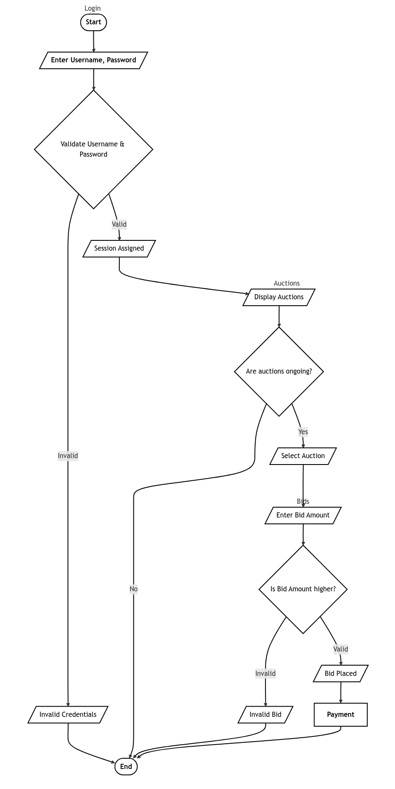
4.3.2 REGISTER
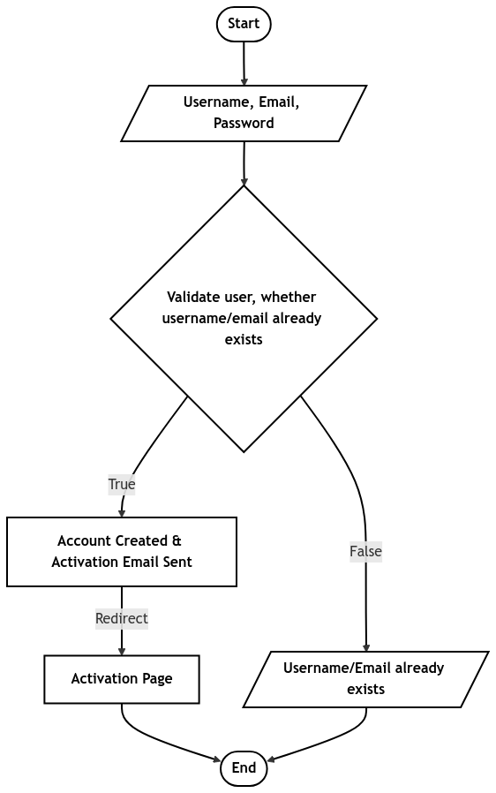

4.3.3 LOGIN
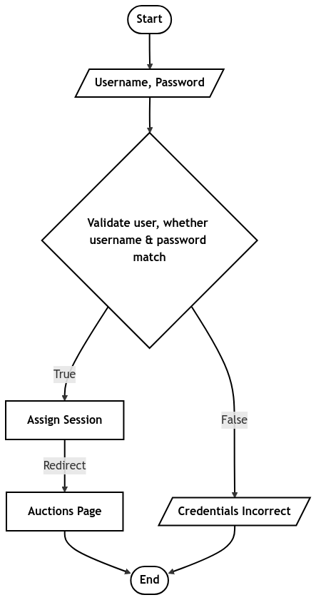

4.3.4 AUCTIONS
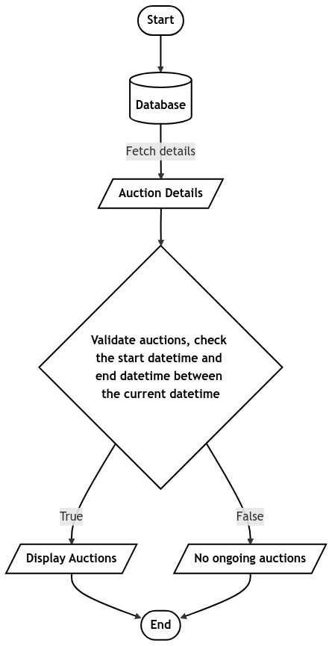

4.3.5 BIDS
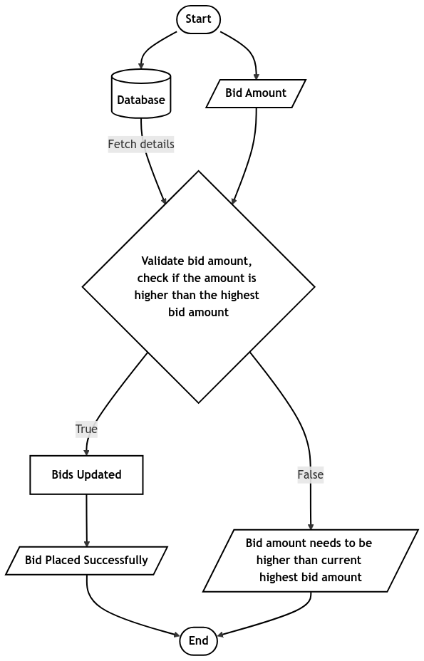

4.3.6 PAYMENT
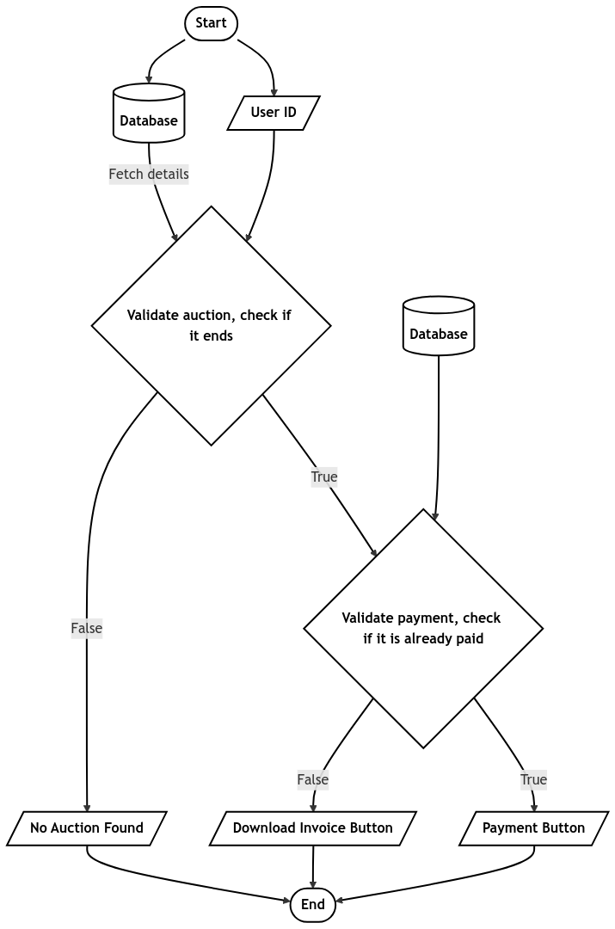

4.3.6 CHATBOT
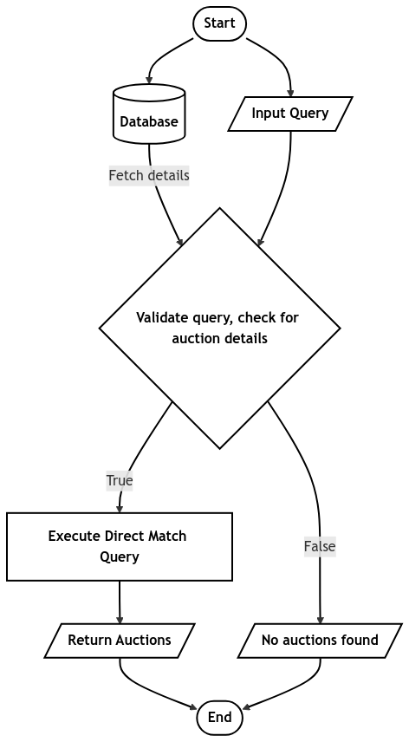
4.4 ER DIAGRAM
4.4.1 USERS
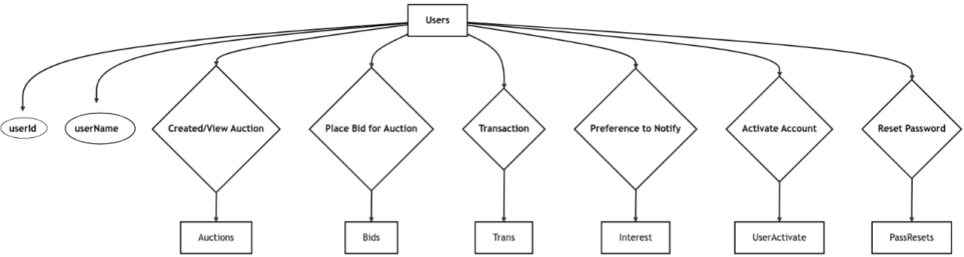

4.4.2 AUCTIONS
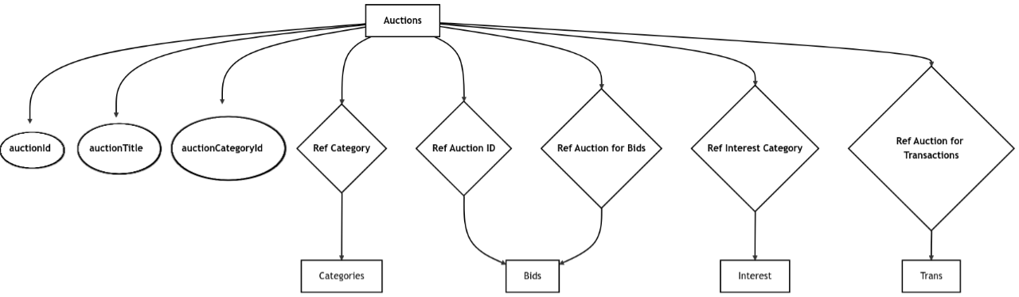

4.4.3 CATEGORIES
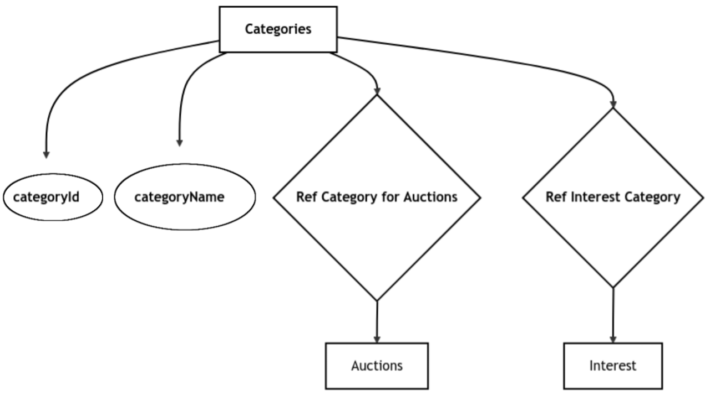

4.4.4 TRANS
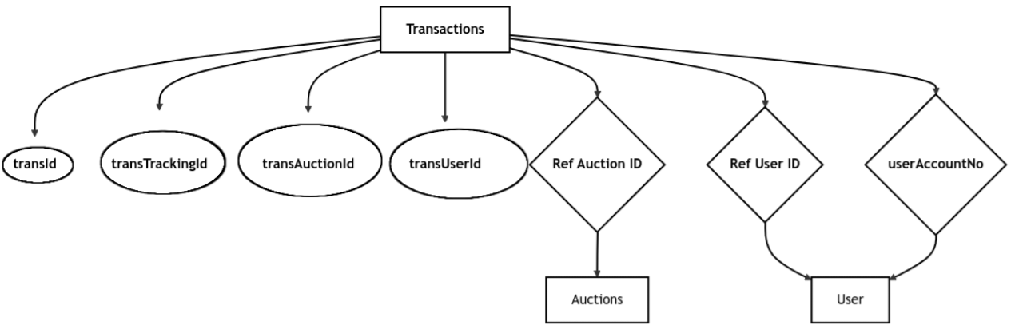
4.4.5 USERS WITH REVIEWS & MOMENTS
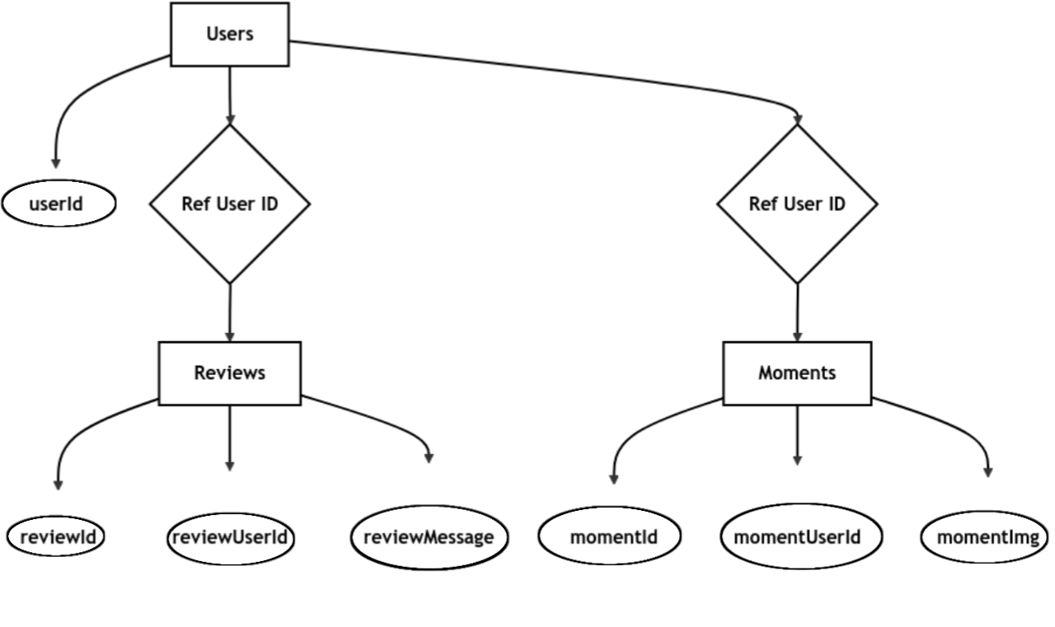

4.5 SCHEMA
Database eAuction
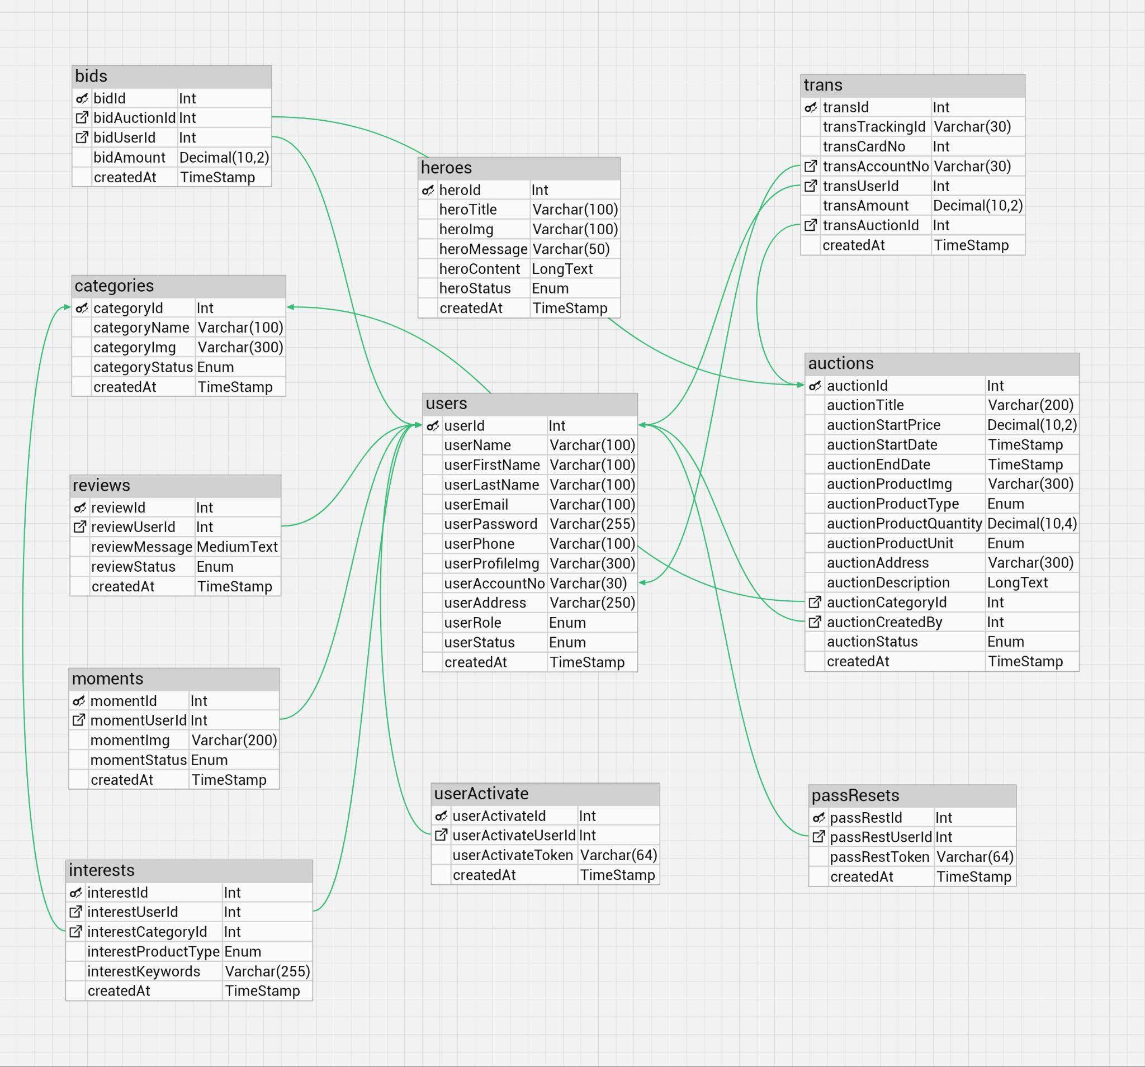

4.6 OUTPUT DESIGN

Output design focuses on presenting processed data in a meaningful and user-friendly manner. The system provides outputs in various forms, ensuring clarity and relevance for the end user.

- USER INTERFACE OUTPUTS
The Auction Page provides users with an overview of all ongoing auctions. It displays essential details such as the product name, starting price, highest current bid, time remaining, and the total number of bids placed. This helps users quickly assess available auctions.
Each auction listing is interactive, allowing users to click and view more details. The page is designed for easy navigation, ensuring that buyers can efficiently browse and select auctions of interest.
The Bidding Page offers a more detailed view of an auction. It includes product specifications, auction status, and a live top bidders list, showing the highest bidders in real time.
Users can place bids directly on the Bidding Page, where the system validates bids against the minimum increment requirement. The page updates dynamically to reflect new bids, ensuring a smooth and competitive bidding experience.
- NOTIFICATIONS AND ALERTS
The Notifications and Alerts Module keeps users informed about important auction activities through automated updates. It ensures that buyers and sellers receive timely information about their transactions and bidding status.
Automated email notifications are sent to users for key events such as new bids, auction closures, and successful transactions. This helps participants stay updated without needing to check the platform constantly.
In addition to emails, real-time alerts provide instant updates on auction progress. Users receive notifications within the platform about bid changes, auction status updates, and payment confirmations.
By delivering timely and relevant information, this module enhances user engagement and ensures a seamless auction experience.
- ADMIN DASHBOARD OUTPUTS
The Dashboard and Analytics Module provides administrators with a comprehensive overview of platform activity. It presents key metrics in a structured format, enabling effective monitoring and decision-making.
The dashboard displays summaries of total users, active auctions, bids placed, and inactive users. This helps administrators track platform engagement and user participation at a glance.
Additionally, interactive charts visualize trends such as user growth, bidding activity, and auction performance over specific periods. These insights help in identifying patterns and improving platform operations.
By offering real-time data and visual analytics, this module enhances platform management, ensuring a seamless and efficient auction experience.
- REPORTS AND INVOICES
The Transaction Records and Reporting Module ensures transparency and accountability by providing users and administrators with detailed records of auction transactions and platform activity.
After a successful payment, the highest bidder can download a transaction invoice, serving as proof of purchase. These invoices include auction details, payment confirmation, and seller information for record-keeping.
For administrators, the module generates comprehensive reports summarizing platform activity, including total bids, completed transactions, and user engagement. These reports assist in monitoring trends and platform performance.
By offering both user-friendly invoices and administrative reports, this module enhances financial transparency and operational oversight, ensuring a smooth and well-documented auction process.

5.0 MODULES
5.1 USERS
5.1.1 REGISTRATION AND LOGIN MODULE
The Registration and Login Module is a fundamental component of the eAgriAuction platform, ensuring secure and controlled access for users. It manages account creation, authentication, and password recovery, providing a seamless onboarding experience while maintaining security standards.
The registration feature allows users to create accounts by providing essential details such as a username, email, and password. To prevent duplicate accounts, the system verifies email addresses and ensures that all required fields are valid before completing the registration process.
To enhance security, passwords are securely stored using encryption techniques. This prevents unauthorized access to user credentials and safeguards sensitive information from potential breaches.
The login functionality authenticates users by verifying their credentials before granting access to the platform. If incorrect details are entered multiple times, the system can implement security measures such as CAPTCHA verification or temporary account lockouts to prevent unauthorized access attempts.
For users who forget their passwords, the password recovery feature allows them to reset their credentials through email verification. A secure link is sent to the registered email address, enabling them to set a new password while preventing unauthorized resets.
Additionally, the module includes session management, ensuring users remain logged in securely during their active sessions while automatically logging them out after periods of inactivity. This helps protect accounts from unauthorized use.
By implementing robust authentication measures, the Registration and Login Module enhances platform security and provides a seamless user experience, allowing farmers and buyers to access auctions securely.

5.1.2 AUCTION MANAGEMENT MODULE
The Auction Management Module is a crucial part of the eAgriAuction platform, enabling sellers to create, edit, and manage auctions efficiently. This module ensures that agricultural products are listed with accurate details and provides sellers with control over their auctions before bidding begins.
The Auction Creation feature allows sellers to list their products for bidding by entering essential details such as the product name, description, starting price, auction duration, and images. Providing comprehensive information ensures that buyers can make informed decisions before placing bids.
To offer flexibility, the Auction Editing feature enables sellers to modify their listings before bidding starts. They can update product descriptions, adjust pricing, or extend/reduce the auction duration based on market conditions or changes in availability. This prevents misinformation and improves the accuracy of listings.
The Auction Deletion feature allows sellers to remove auctions that have not yet received any bids. This prevents inactive, incorrect, or unnecessary listings from cluttering the platform, maintaining a streamlined and organized auction system.
Additionally, the module incorporates status tracking, which helps sellers monitor the progress of their auctions, including the number of bids received and the current highest bid. This feature ensures that sellers remain informed about their ongoing auctions.
To enhance user experience, the platform may also include automated notifications that inform sellers about auction updates, such as when bidding begins, when their auction is about to close, or when a product is successfully sold.
The Auction Management Module ensures smooth auction operations by providing sellers with the necessary tools to manage their listings effectively. By maintaining platform integrity and preventing auction-related discrepancies, this module contributes to a transparent and efficient agricultural auction system.

5.1.3 BIDDING MODULE
The Bidding Module is a core component of the eAgriAuction platform, allowing users to actively participate in auctions by placing bids on listed agricultural products. It ensures a smooth, competitive, and transparent bidding process while maintaining platform rules and fairness.
The Bid Placement feature enables registered users to place bids on active auctions. Each bid is recorded in real-time, updating the auction's current highest bid and bid count. This dynamic system ensures that all participants see the latest updates, making the bidding process more engaging.
To help bidders stay competitive, the Top Bidders List displays a live ranking of the highest bidders for an auction. This feature allows users to track bidding activity and strategize accordingly. It also adds excitement to the auction process by fostering a sense of competition among buyers.
The Bid Validation mechanism ensures that all bids comply with platform rules. Each bid must meet the minimum increment requirement, ensuring that prices increase in a structured manner. Additionally, bids must be placed within the auction’s active duration—any bid submitted after the auction ends is automatically rejected. This prevents manipulation and ensures a fair bidding environment.
To maintain transparency, the module includes bid history tracking, allowing users to view past bids and analyze auction trends. This feature enhances user confidence by providing clear records of all bidding activities.
For a seamless experience, the system may also include automated notifications, informing users when they are outbid or when an auction, they participated in is about to close. This keeps buyers engaged and increases their chances of winning the auction.
The module can also include anti-fraud features to detect suspicious bidding or bots trying to manipulate auctions, keeping the platform secure and fair for everyone.
Overall, the Bidding Module plays a crucial role in fostering fair competition, encouraging active participation, and maintaining transparency within the eAgriAuction platform.
5.1.4 NOTIFICATION AND COMMUNICATION MODULE
The Notification and Communication Module is an essential part of the eAgriAuction platform, ensuring that users receive timely updates and can interact seamlessly. This module enhances user engagement by providing real-time notifications and facilitating direct communication between buyers and sellers.
The Email Notification feature delivers automated alerts for important auction events. Users receive emails when a new bid is placed, when an auction is about to close, or when a transaction is completed. These updates help participants stay informed without needing to constantly check the platform. Additionally, payment reminders are sent to successful bidders to ensure timely transactions.
To further assist users, the Chatbot Interaction feature provides instant responses to common queries. It helps users navigate the platform, find relevant auctions, and understand the bidding process. The chatbot enhances the overall user experience by offering real-time guidance and reducing the need for manual support.
The module also includes a Messaging System, allowing users to communicate directly within the platform. Buyers and sellers can discuss product details, negotiate terms, or clarify auction-related concerns. This secure messaging feature ensures that all auction-related interactions remain within the platform, improving trust and transaction efficiency.
For real-time updates, the module supports Push Notifications, instantly notifying users of bid status changes, auction deadlines, and other critical activities. These alerts enhance engagement by keeping participants actively involved in the auction process.
Additionally, the Admin Announcement Feature enables platform administrators to send important messages to all users. This can include policy updates, system maintenance notices, or general auction guidelines to ensure smooth operations.
By integrating multiple communication channels, the Notification and Communication Module strengthens user engagement, enhances auction transparency, and fosters a more interactive and informed bidding environment.

5.1.5 PAYMENT MODULES
The Payment Module is a crucial component of the eAgriAuction platform, ensuring secure and efficient transactions between buyers and sellers. It provides a reliable payment system that facilitates smooth financial transactions for completed auctions, enhancing trust and transparency.
Buyers can make payments using debit or credit cards, ensuring fast and secure transactions. The platform integrates a secure payment gateway that encrypts sensitive information, protecting user data from fraud and unauthorized access. Once a payment is processed successfully, the buyer receives a confirmation, and the seller is notified immediately.
To enhance transparency, the module includes a payment tracking system, allowing users to monitor their transaction statuses. Buyers can verify whether their payments have been successfully processed, while sellers can check when funds are transferred to their accounts. This reduces disputes and ensures a hassle-free transaction experience.
Additionally, the invoice generation feature provides downloadable receipts for each transaction. Buyers receive a detailed invoice summarizing the auction details, payment confirmation, and seller information, which serves as proof of purchase for record-keeping.
To maintain transaction integrity, the module implements fraud detection mechanisms, such as monitoring unusual payment activity and flagging suspicious transactions. This ensures that only legitimate payments are processed, protecting both buyers and sellers from fraudulent activities.
For further convenience, the platform may support automated refunds and dispute resolution, allowing buyers to request refunds if an issue arises, such as non-delivery of goods. Sellers are also protected by structured dispute-handling procedures, ensuring fair resolution of payment-related conflicts.
By streamlining the payment process, ensuring security, and providing tracking capabilities, the Payment Module enhances user confidence and ensures smooth financial transactions within the eAgriAuction platform.

5.2 ADMINS:
This module empowers administrators to monitor and manage platform activities effectively.

5.2.1 USER MANAGEMENT
The User Management Module is designed to help administrators oversee platform users, ensuring a secure and well-regulated environment. It provides essential tools to manage user activity, enforce platform policies, and maintain a trustworthy auction system.
Administrators can view, suspend, or delete users based on compliance with platform guidelines. If a user violates policies or engages in suspicious activities, their account can be suspended, restricting access to auctions and bidding. This measure helps maintain system integrity and prevents fraudulent participation.
The module also includes user approval functionality, allowing administrators to activate inactive accounts after verification. This ensures that only genuine users gain full access to the platform, reducing the risk of spam or fraudulent accounts.
To enhance security, the system may include audit logs, which track administrative actions taken on user accounts. This allows platform managers to monitor user management activities and ensure transparency in decision-making.
By providing structured user oversight, the User Management Module helps maintain a secure, fair, and well-regulated auction environment within the eAgriAuction platform.

5.2.2 AUCTION MANAGEMENT
The Auction Monitoring Module enables administrators to oversee and regulate auctions, ensuring that all listings adhere to platform policies and maintain marketplace integrity. By actively monitoring auctions, admins can prevent fraudulent activities and enforce compliance with established guidelines.
Administrators have the ability to view all auctions created by users, tracking both ongoing and completed listings. This allows them to monitor auction activity, verify product authenticity, and ensure that auctions are conducted fairly.
If an auction violates platform guidelines—such as containing misleading information, prohibited items, or suspicious bidding behavior—admins can suspend or delete the listing. This prevents users from exploiting the system and protects buyers from potential scams.
The module may also include automated flagging mechanisms, where suspicious auctions are highlighted based on predefined criteria, such as unusually high starting prices, repeated rule violations, or sudden changes in auction details.
By ensuring compliance with rules and preventing misuse, the Auction Monitoring Module helps maintain a fair, transparent, and trustworthy auction environment within the eAgriAuction platform.

5.2.3 BID MANAGEMENT
The Bid Monitoring Module allows administrators to track and regulate bidding activities, ensuring a fair and competitive auction environment. By overseeing bid placements, admins can detect and prevent fraudulent or manipulative behavior that could impact auction integrity.
Administrators can track all bids, spotting issues like sudden price jumps, bot bids, or attempts to manipulate auctions. This helps ensure transparency and fairness on the platform. In addition to real-time tracking, the module enables admins to generate detailed reports on bidding trends. These reports provide insights into user engagement, auction performance, and market demand, helping the platform refine its bidding policies and improve user experience.
To enhance security, the system may include automated alerts that flag suspicious bidding patterns, allowing administrators to take swift action against potential rule violations.
The Bid Monitoring Module ensures fair competition and prevents bid manipulation, maintaining the integrity of the eAgriAuction platform and building trust between buyers and sellers.

5.2.4 REVIEW AND MOMENTS MANAGEMENT
The Review and Moments Management Module enables administrators to oversee user-submitted reviews and shared moments, ensuring that all content aligns with platform guidelines. This module plays a key role in maintaining content quality, fostering trust, and promoting meaningful interactions among users.
Administrators can approve or suspend reviews and moments based on their relevance and adherence to community standards. If any content contains inappropriate language, misleading claims, or violates platform policies, admins can take immediate action to remove or modify it.
By ensuring that only genuine and constructive feedback is displayed, the module helps buyers make informed decisions while protecting sellers from false or harmful reviews. It also prevents spam and promotional misuse, ensuring that the platform remains a reliable marketplace.
To streamline content moderation, the system may include automated filtering tools that flag potentially inappropriate content for admin review. These tools help in efficiently managing large volumes of user-generated content while maintaining a positive community atmosphere.
By balancing user engagement and content integrity, the Review and Moments Management Module ensures that the eAgriAuction platform remains a trusted and professional space for agricultural trading.

5.2.5 DASHBOARD AND REPORTING FEATURES
The Dashboard and Reporting Module provides administrators with real-time insights into platform activity, enabling effective monitoring and data-driven decision-making. By offering a comprehensive overview of key metrics, this module helps ensure smooth platform operations and improved user engagement.
The real-time dashboard displays critical statistics such as total users, active auctions, bids placed, and other essential data. This allows administrators to track platform engagement at a glance, identifying trends and potential issues that require attention.
In addition to live tracking, the module generates visual reports and charts that highlight trends in user growth, bidding activity, and auction performance over specific periods. These insights help administrators analyze market behavior and optimize platform strategies for better efficiency.
To enhance usability, the system may offer customizable reporting tools, allowing admins to filter and analyze data based on specific parameters such as auction categories, user demographics, or seasonal trends.
By offering real-time monitoring and analytical reporting, the Dashboard and Reporting Module helps administrators maintain transparency, efficiency, and continuous improvement within the eAgriAuction platform.

6.0 SYSTEM IMPLEMENTATION
System implementation is a crucial phase where the eAgriAuction platform is transformed from design and development into a fully functional and operational system. This process involves deploying the system, integrating its various modules, and ensuring smooth functionality across all components. The implementation follows a structured approach, ensuring that the platform is stable, secure, and ready for use.
The deployment process begins with setting up the necessary hardware and software infrastructure. This includes configuring servers, installing essential software, and setting up the MySQL database for efficient data management. Additionally, the web server is configured to ensure seamless communication between the frontend and backend components.
The frontend is developed using PHP, HTML5, Bootstrap, and jQuery, ensuring a responsive and user-friendly interface for both buyers and sellers. These technologies enhance the platform's usability, making it accessible across various devices while maintaining an intuitive design. The backend is structured to support critical functionalities such as user authentication, auction management, bidding, notifications, and chatbot interactions.
To ensure reliability, the implementation phase includes rigorous testing to identify and fix bugs, optimize system performance, and validate key functionalities. Once testing is complete, the system is deployed on a live server, allowing users to access the platform through their browsers. Continuous monitoring and maintenance are conducted to ensure smooth operation and address any potential issues.

7.0 SYSTEM TESTING

7.1 TESTING
System testing is a critical phase in the development process to ensure the eAgriAuction platform functions as intended. Various types of testing are performed to identify and fix errors, validate requirements, and optimize performance. Below are the key aspects of testing:

TYPES OF TESTING
- Unit testing
- Integration testing
- System Testing
- Regression Testing
- User Acceptance Testing (UAT)
- Performance Testing
- Security Testing

7.1.1 UNIT TESTING
Unit testing involves verifying the functionality of individual modules or components to ensure they perform as expected.
- Objective: To validate the correctness of individual units like registration, login, bidding, and auction creation.
- Tools Used: PHPUnit for PHP-based backend testing.
Example:
The registration module is tested to verify input validation for fields such as email and password, ensuring only valid data is accepted. It checks for proper email formatting, strong password requirements, and prevention of duplicate accounts.
Additionally, the system is tested for error handling and security measures, such as displaying appropriate validation messages and preventing SQL injection or unauthorized access attempts.

7.1.2 INTEGRATION TESTING
Integration testing ensures that different modules work together seamlessly.
- Objective: To validate interactions between modules like auction creation, bidding, and notifications.
Types:
- Top-Down Testing: Starts testing from the main modules and integrates lower-level modules incrementally.
- Bottom-Up Testing: Begins testing from lower modules and integrates upwards.
Example:
The module verifies that bids are correctly recorded, meeting auction rules like minimum increments and time constraints. It ensures real-time updates for active auctions.
Additionally, it tests interactions with user accounts, validating bidder eligibility and preventing unauthorized or invalid bids.

7.1.3 SYSTEM TESTING
System testing validates the entire system to ensure it meets specified requirements.
- Objective: To test the system end-to-end for functionality and performance.
Types:
- Functional Testing: Validates core functionalities like user authentication and auction management.
- Non-Functional Testing: Evaluates performance, scalability, and usability.
Example:
The chatbot is tested to ensure it understands user queries and provides relevant auction suggestions based on keywords and preferences. It verifies accurate responses for product searches and bidding details.
Additionally, the system checks for response efficiency, proper handling of unclear queries, and seamless integration with the auction database for real-time updates.

7.1.4 REGRESSION TESTING
Regression testing ensures that new updates or changes do not affect the existing functionalities.
- Objective: To test previously validated features after modifications.
- Tools Used: Selenium for automated regression testing.
Example:
The system is tested to ensure automated email reminders are sent for key events like bid updates, auction closures, and payment confirmations. It verifies timely delivery and accurate content.
Additionally, tests check for proper recipient targeting, error handling in case of failures, and seamless integration with the platform’s event triggers.

7.1.5 USER ACCEPTANCE TESTING (UAT)
UAT verifies the system’s readiness for deployment by testing it with end-users.
- Objective: To ensure the system meets user needs and is user-friendly.
- Stakeholders: Farmers, bidders, and administrators.
Example:
The system gathers user feedback on auction creation and bidding to evaluate ease of use, functionality, and overall experience. It helps identify areas for improvement.
Additionally, feedback analysis ensures that user concerns are addressed, enhancing the platform’s efficiency and user satisfaction.

7.1.6 PERFORMANCE TESTING
Performance testing evaluates the system's responsiveness, stability, and scalability under different conditions.
- Objective: To assess system behavior under load.
Types:
- Load Testing: Tests the system under expected user loads.
- Stress Testing: Tests system behavior under extreme conditions.
- Tools Used: JMeter for simulating traffic.

Example:
The system is tested by simulating 500 simultaneous bids on a single auction to assess performance, response time, and database stability under high load. It ensures smooth processing without delays or crashes.
Additionally, the test verifies that bid records are accurately updated in real-time, preventing duplicate or failed transactions while maintaining fair competition.
7.1.7 SECURITY TESTING
Security testing ensures that the system is safeguarded against potential vulnerabilities and threats.
- Objective: To protect user data and ensure system integrity.
Types:
- Vulnerability Testing: Identifies weaknesses in the system.
- Penetration Testing: Simulates attacks to evaluate security measures.
- Tools Used: OWASP ZAP for vulnerability scanning.

Example:
The login module is tested for SQL injection vulnerabilities by attempting to inject malicious queries into input fields. This ensures that the system properly sanitizes and validates user inputs.
Additionally, the test verifies the effectiveness of prepared statements and parameterized queries, preventing unauthorized access and ensuring database security.
8.0 SOFTWARE FEATURES
To improve the functionality and user experience of the eAgriAuction platform, several feature enhancements have been introduced. These upgrades focus on better performance, enhanced security, improved user interaction, and seamless auction management. The enhancements ensure a more reliable and efficient system, catering to the needs of both buyers and sellers while maintaining platform integrity.

8.1 PHP (Hypertext Preprocessor)
- Server-side scripting language used for dynamic content generation.
- Allows for integration with databases (e.g., MySQL, MariaDB) to manage user data, auctions, and bids.
- Supports object-oriented programming (OOP) principles for better code organization and maintainability.
8.2 HTML5 (Hypertext Markup Language)
- Provides the structure for web pages with enhanced semantic tags.
- Allows embedding multimedia (audio, video) and interactive forms.
- Supports responsive design to ensure the platform works across devices (desktop, tablet, mobile).
8.3 CSS3 (Cascading Style Sheets)
- Styles the HTML content, providing an attractive layout and design for the platform.
- Ensures responsiveness through media queries, adapting the layout based on device size.
- Supports animations and transitions for interactive user interfaces.
8.4 BOOTSTRAP
- A popular front-end framework for designing responsive web applications.
- Provides a grid system, pre-designed UI components (buttons, forms, modals), and customizable themes.
- Ensures the system is mobile-friendly and adaptive to different screen sizes.

8.5 JS(JavaScript)
- JavaScript enhances the platform by enabling interactive features such as real-time bid updates, countdown timers for auctions, and live notifications, improving user engagement.
- It ensures secure and efficient user input validation, preventing incorrect or malicious data submissions during registration, login, and bidding processes.
- JavaScript uses AJAX and the Fetch API to load data without refreshing the page, allowing smooth bidding, notifications, and chatbot interactions.
8.6 MySQL
- Open-source relational database management system (RDBMS) used to store and manage platform data such as users, bids, auctions, and reviews.
- High performance with scalability options to handle large datasets.
- Provides advanced security features like encryption for protecting sensitive user data.
8.7 APACHE WEB SERVER
- Open-source web server that serves web pages to users.
- Supports PHP integration for dynamic content generation.
- Reliable and scalable, ensuring smooth handling of multiple requests simultaneously.

9.0 CONCLUSION

The "E-Agriculture for Direct Marketing of Food Crops Using Chatbot" project aims to revolutionize the agricultural trading landscape by offering a direct and efficient platform for farmers and buyers. By eliminating middlemen, the system empowers farmers to sell their products at fair prices, while buyers gain access to a wide range of agricultural goods. The integration of a Chatbot allows for real-time interaction, making it easier for users to navigate the platform and find relevant auctions. Automated email notifications further enhance communication, ensuring that both sellers and buyers stay informed about bidding activities and auction status.

This platform not only improves the efficiency of agricultural trading but also increases transparency and trust between sellers and buyers. By streamlining the process and providing an intuitive interface, the system enhances the overall user experience and promotes active participation. Ultimately, the project aims to create a more profitable, sustainable, and accessible marketplace for farmers, helping to strengthen their financial standing and facilitate the growth of the agricultural sector.

10.0 FUTURE ENHANCEMENT

1. Integration of Real-Time Payment Gateway
One of the most significant enhancements to the eAgriAuction portal would be the integration of a real-time payment gateway. This feature would allow bidders to make instant payments once they win an auction, eliminating delays in the transaction process. Popular payment solutions like UPI, PayPal, Razorpay, or Stripe can be incorporated to support multiple payment options, catering to a diverse user base. Real-time payments ensure a seamless and secure transfer of funds, improving trust and reducing payment-related disputes.

2. Advanced Analytics and Insights
Incorporating advanced analytics features can provide users with actionable insights into auction trends, market prices, and bidding patterns. Farmers could analyze historical data to set optimal base prices for their products, while buyers can use trend predictions to make informed bidding decisions. Additionally, an admin panel with detailed reports on user engagement, top-performing auctions, and revenue metrics can help administrators monitor and optimize platform performance effectively.

3. Mobile Application Development
To make the platform more accessible, a dedicated mobile application for both Android and iOS can be developed. This app would enable users to participate in auctions on the go, receive instant notifications, and manage their accounts effortlessly. Push notifications for bid updates, payment reminders, and auction end alerts can significantly enhance user engagement. Moreover, offline capabilities, such as creating bids or reviewing past auctions, can be implemented to benefit users with limited internet access.

4. Enhanced Chatbot Functionality
The current chatbot can be upgraded with AI and machine learning capabilities to provide more personalized and accurate assistance. The chatbot could handle complex queries, recommend auctions based on user preferences, and even assist with troubleshooting payment issues. Multilingual support can also be added to cater to farmers and buyers from diverse linguistic backgrounds, making the platform more inclusive. This enhancement will improve user experience and keep the platform user-friendly for all.
11.0 BIBLIOGRAPHY

Books

- [N. T. Yaduraju, J. Woodard, G. Sylvester, A. Narayan, and H. Eskandar], "E-Agriculture Strategy Guide", FAO Publications, First Edition.
- http://www.fao.org/3/a-i5569e.pdf
- James Barham, "Direct Marketing of Agricultural Products", USDA Publications, Second Edition.
- https://www.ams.usda.gov/services/local-regional/direct-marketing
- Timothy Kelley, "The Role of ICT in Agriculture", World Bank Publications, Third Edition.
- https://openknowledge.worldbank.org/handle/10986/21736
- David C. Wyld, "Online Bidding Systems", IEEE Publications, Fourth Edition.
- https://ieeexplore.ieee.org/document/6415424

Web Resources

- https://stackoverflow.com/
- https://www.w3schools.com/
- https://chat.openai.com/
- https://xai.com/grok
- https://github.com/

12.0 APPENDIX

12.1 SCREENSHOT

[Fig.1 Login Page]

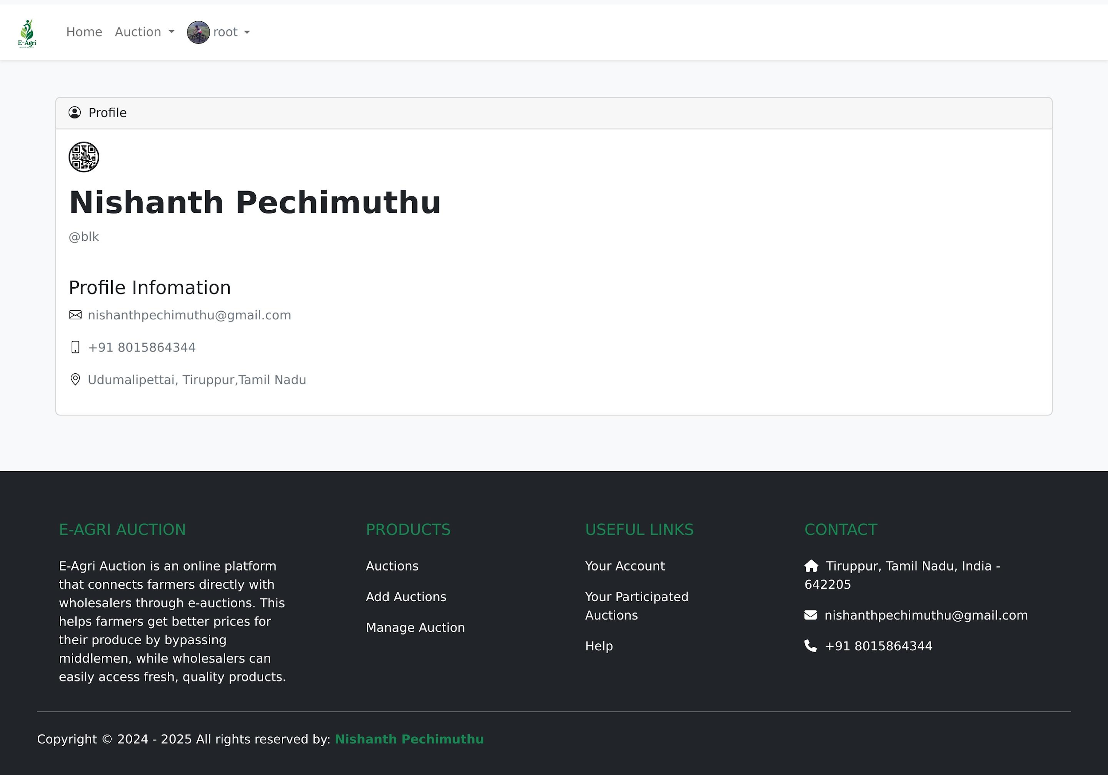
[Fig.2 Profile Page]

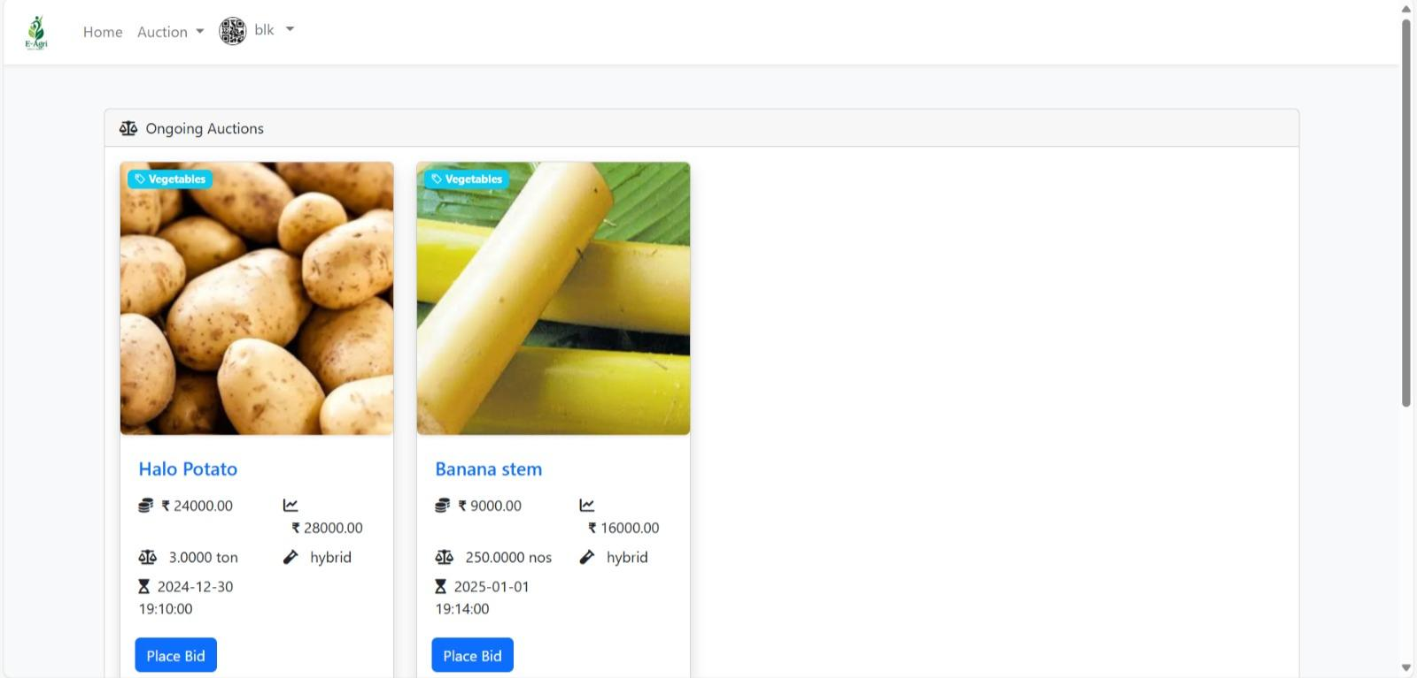
[Fig.3 Auction Page]
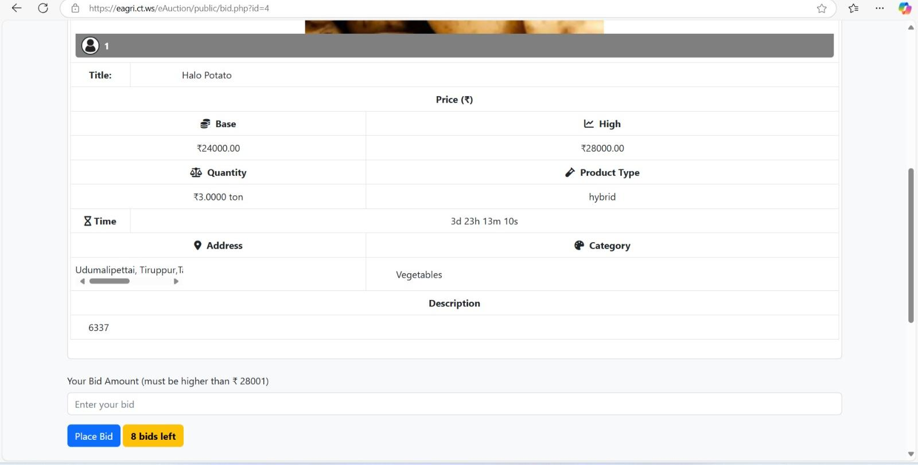
[Fig.4 Bid Page]

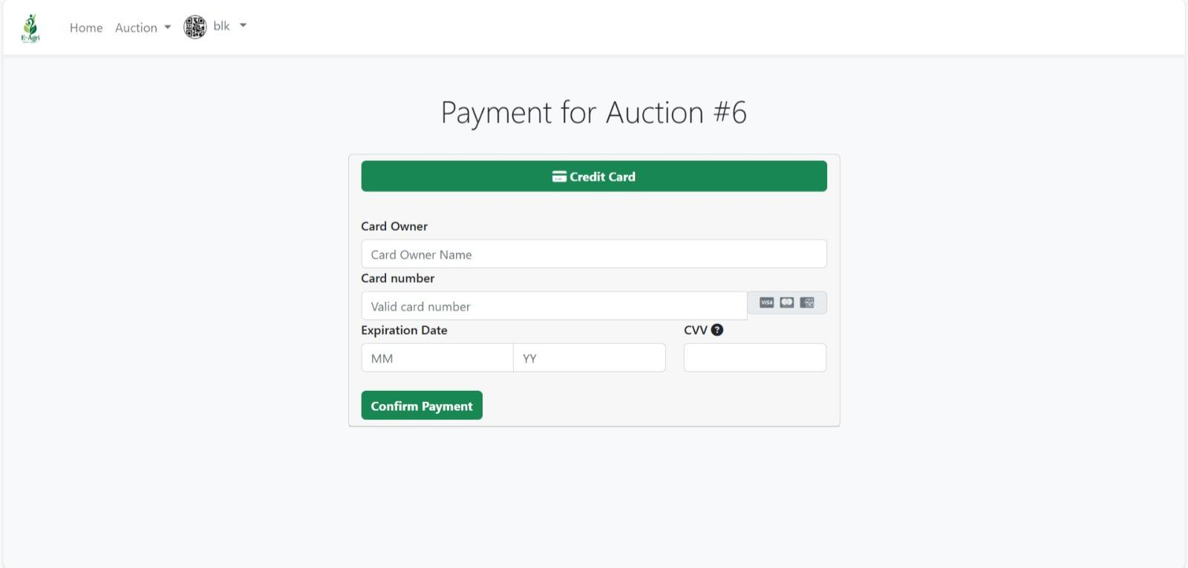
[Fig.5 Payment Page]
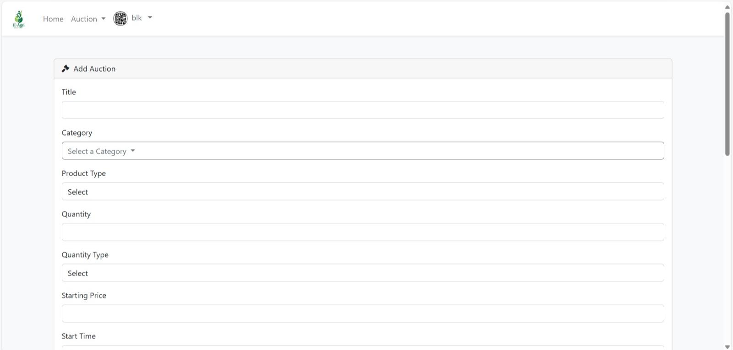
[Fig.6 Add Auction Page]
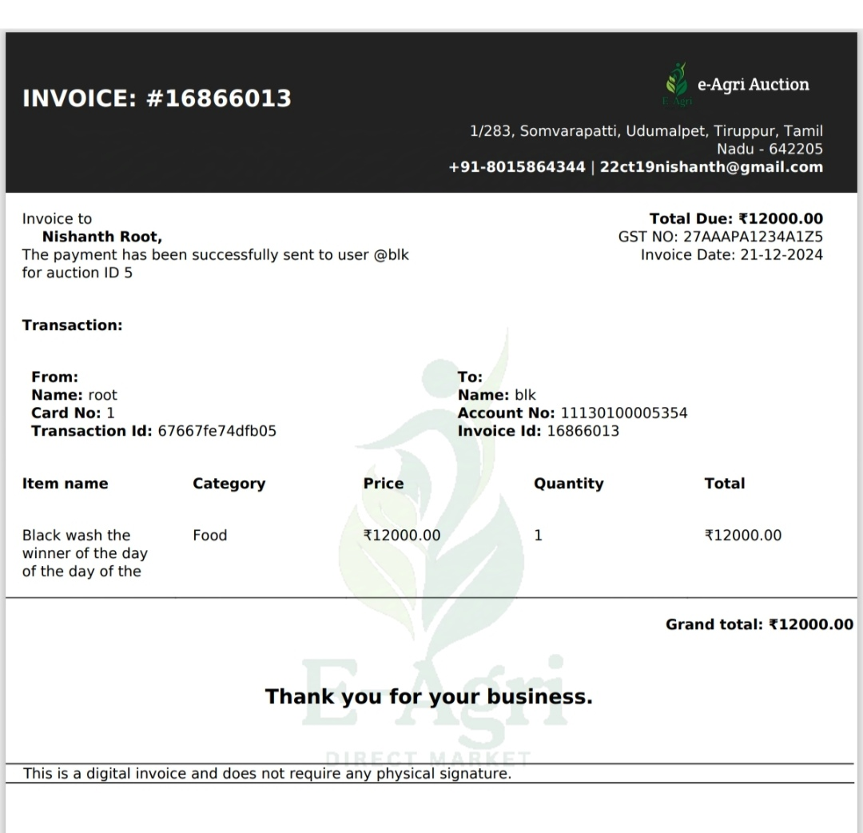
[Fig.7 Invoice]
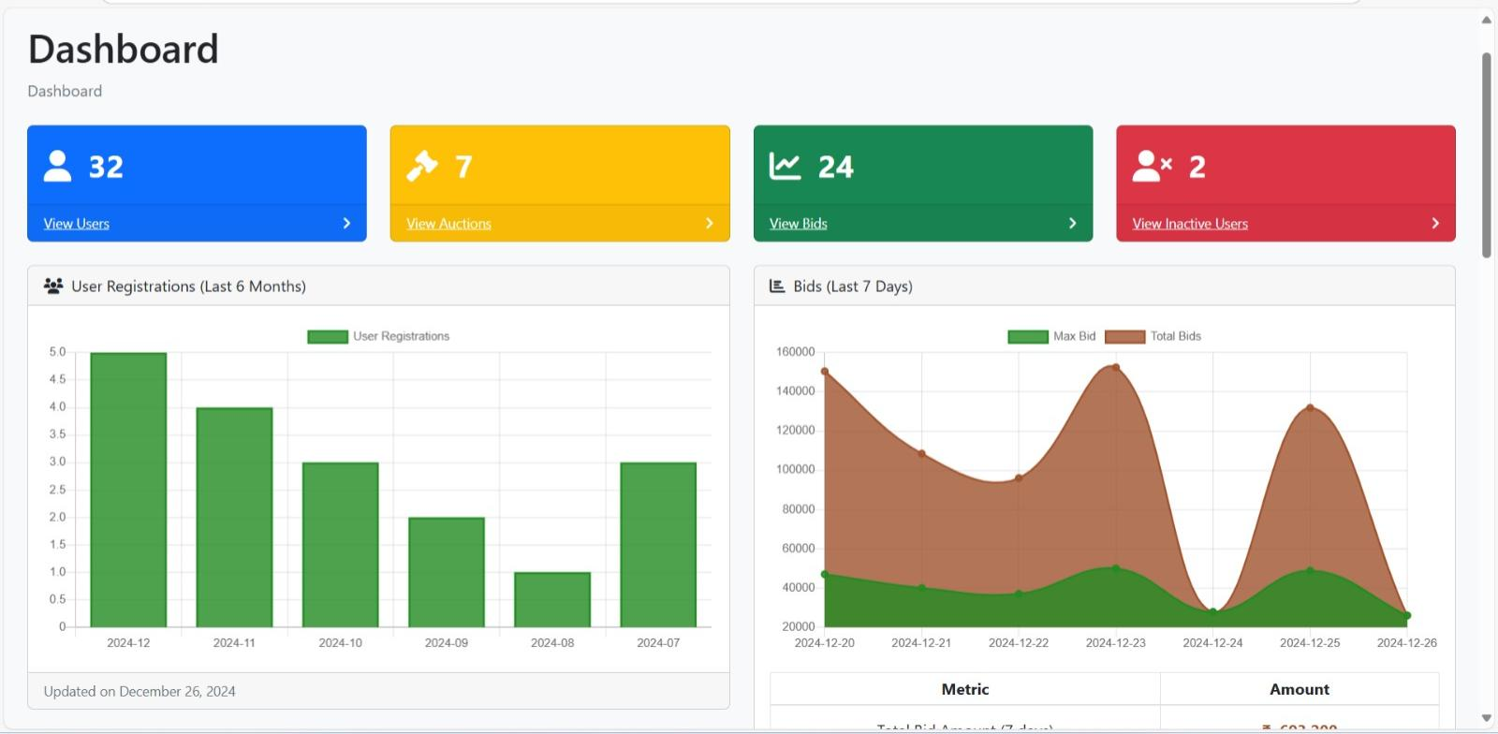
[Fig.8 Dashboard Page]
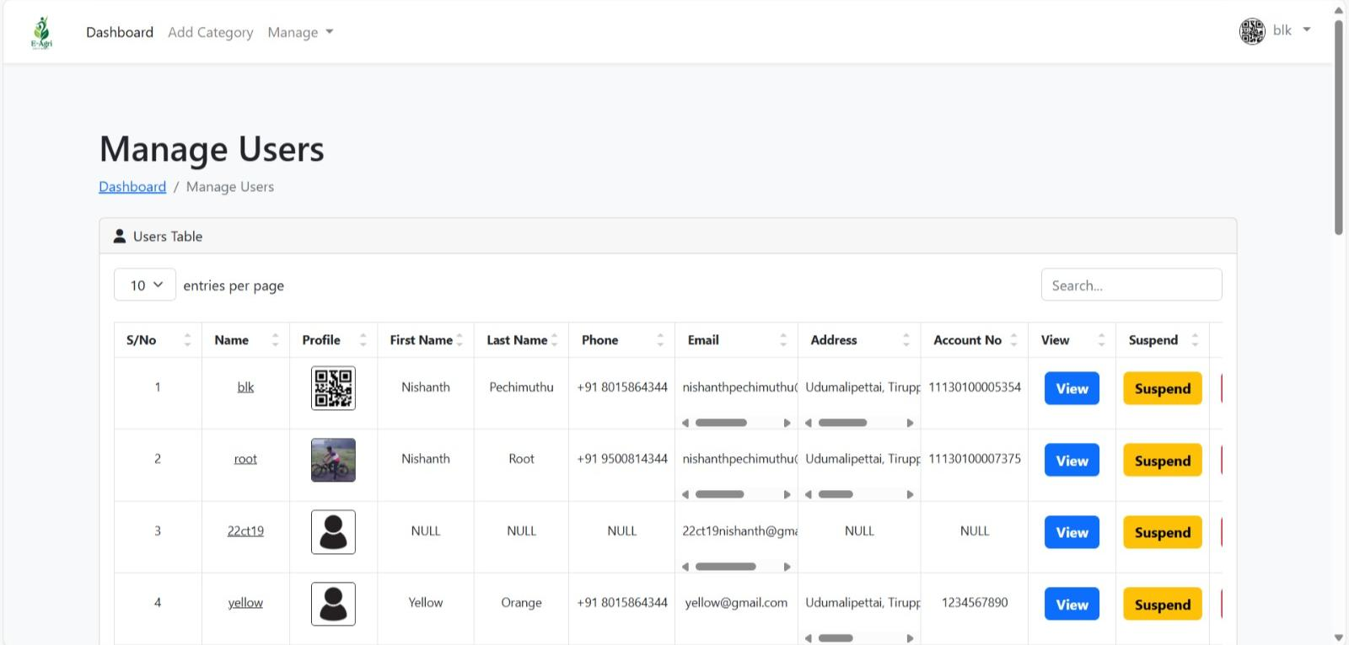
[Fig.9 Manage User]
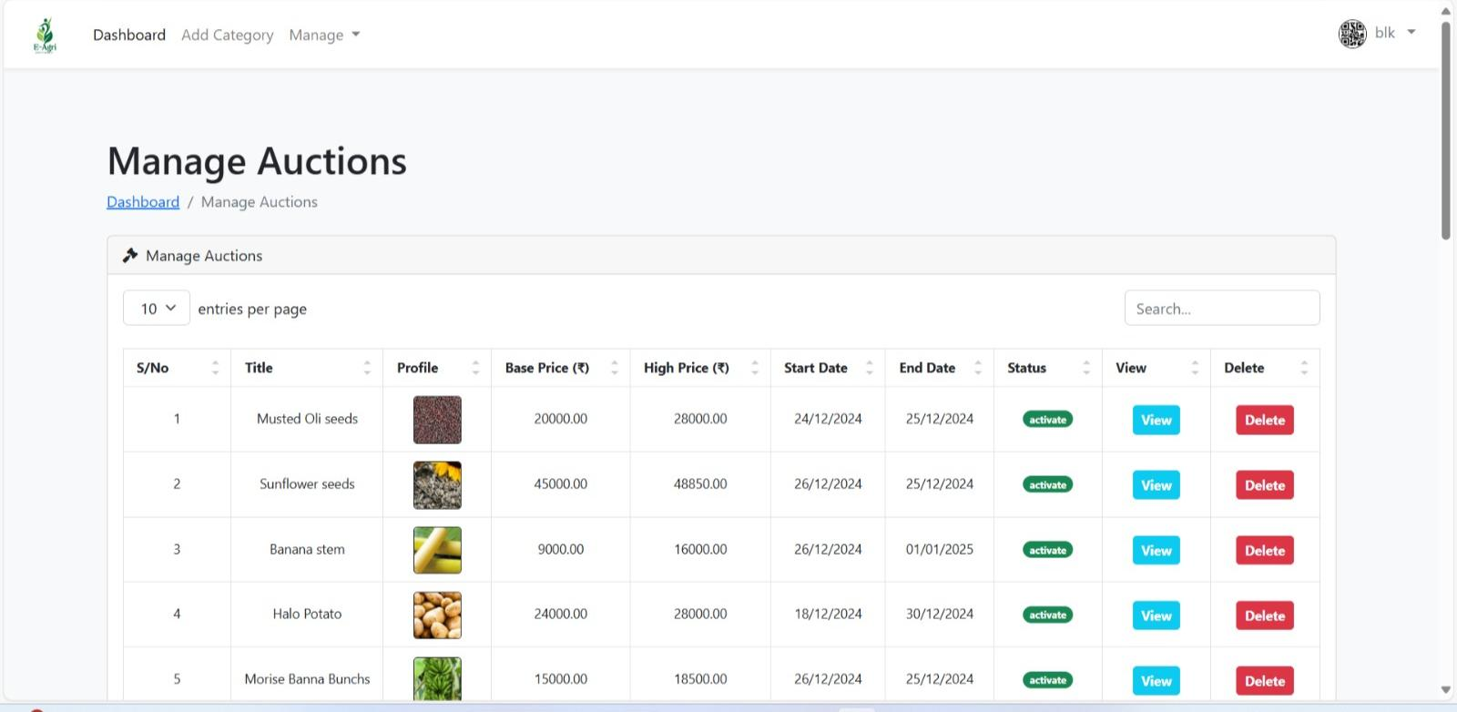
[Fig.10 Manage Auction]

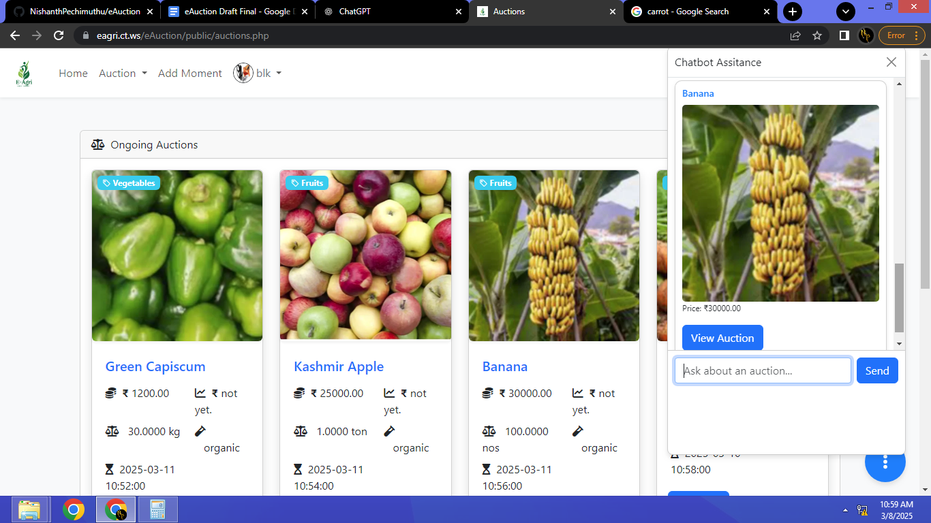
[Fig.11 Chatbot]
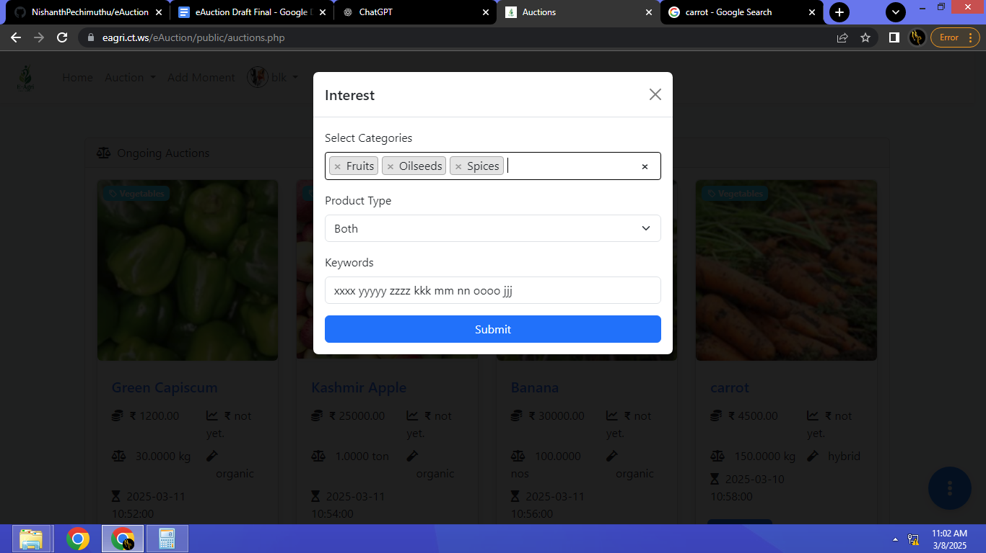
[Fig.12 Notify ]
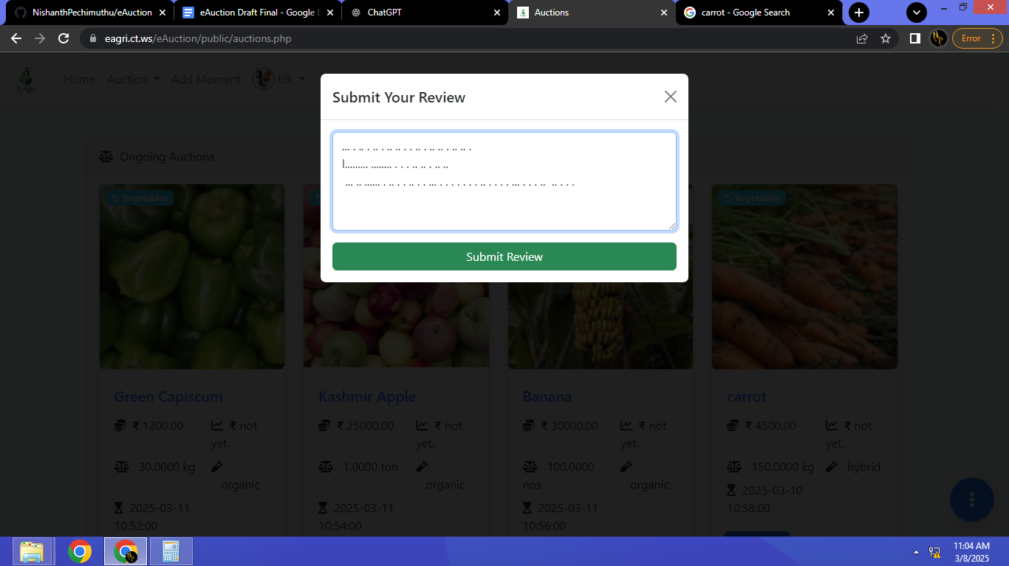
[Fig.13 Review]
12.2 SAMPLE CODING
<?php
Include_once(“header.php”);
If (isset($_SESSION[“userId”]) && $_SESSION[“userId”] != NULL) {
Header(“Location: auctions.php”);
Exit();
}
If ($_SERVER[‘REQUEST_METHOD’] === ‘POST’) {
$username = $_POST[‘username’];
$password = $_POST[‘password’];

If (login($username, $password)) {
Header(“Location: auctions.php”);
Exit();
}
}
?>
<!DOCTYPE html>
<html lang=”en”>
<head>
<meta charset=”UTF-8”>
<meta http-equiv=”X-UA-Compatible” content=”IE=edge”>
<meta name=”viewport” content=”width=device-width, initial-scale=1.0”>
<?php include_once(“../assets/link.html”); ?>
<link rel=”stylesheet” href=”
../assets/style.css”>
<title>Login</title>
</head>
<body>

<div class=”container d-flex justify-content-center align-items-center min-vh-100”>

<div class=”row border rounded-5 p-3 bg-white shadow box-area”>

<div class=”col-md-6 rounded-4 d-flex justify-content-center align-items-center flex-column left-box” style=”background: rgb(1,255,202);background: linear-gradient(45deg, rgba(1,255,202,1) 0%, rgba(204,255,0,1) 100%);”>
<div class=”featured-image mb-3”>
<img src=”../images/logo/1.png” class=”img-fluid” style=”width: 250px;”>
</div>
<p class=”text-white fs-2” style=”font-family: ‘Courier New’, Courier, monospace; font-weight: 800;color:#000000;”>
Be Verified
</p>
<small class=”text-dark text-wrap text-center” style=”width: 17rem;font-family: ‘Courier New’, Courier, monospace;”>Make the auction genuine.</small>
</div>

<div class=”col-md-6 right-box”>
<div class=”row align-items-center”>
<div class=”header-text mb-4”>
<h2>Hello,Again</h2>
<p>
We are happy to have you back.
</p>
</div>
<form method=”post” accept-charset=”utf-8”>
<div class=”input-group mb-3”>
<input name=”username” type=”text” class=”form-control form-control-lg bg-light fs-6” placeholder=”username”>
</div>
<div class=”input-group mb-1”>
<input name=”password” type=”password” class=”form-control form-control-lg bg-light fs-6” placeholder=”Password”>
</div>
<div class=”input-group mb-5 d-flex justify-content-between”>
<div class=”form-check”>
</div>
<div class=”forgot”>
<small><a href=”forgot-password.php”>Forgot Password?</a></small>
</div>
</div>
<div class=”input-group mb-3”>
<input type=”submit” value=”Log in”
Class=”text-white fw-bold btn btn-lg w-100 fs-6”
Style=”background: linear-gradient(45deg, rgba(204,255,0,1) 0%, rgba(1,255,202,1) 100%);”>
</div>
</form>
<div class=”row”>
<small>Don’t have account? <a href=”register.php”>Register</a></small>
</div>
</div>
</div>

</div>
</div>
</body>
</html>

